## Facilitator Training Workshop Overview

### Overview of the Workshop

| Goals of the workshop | * Participants can articulate the purpose of Crianza con Conciencia+ * Participants are familiar with the Crianza con Conciencia+ chatbot technology * Participants have observed the demonstration of the in-person onboarding session for Crianza con Conciencia+ * Participants can use the Formando Conciencia+ App to connect parents’ unique identifier, and report attendance * Participants can facilitate chat session on self-talk * Participants can provide parents support with troubleshooting and safeguarding | | | | |
| --- | --- | --- | --- | --- | --- |
| Materials | * Laptop, Internet Connection, Zoom Webinar Credentials | | | | |
| Preparation | * Check all the relevant technology before the session. * All the participants should have access to the Crianza con Conciencia+ chatbot and Formando Conciencia+ App * Polls and quizzes for the workshop should be set up in advance * All participants should have access to a laptop, stable internet connection, and a smartphone | | | | |

| Day 1 Session Agenda | | | | | | |
| --- | --- | --- | --- | --- | --- | --- |
| Module | | Activities | | Zoom Preparation | Time | |
| Module 1: Introduction to the Programme | | * Welcome and Introductions * Overview of Facilitator Training Workshop and Crianza con Conciencia+ | | Getting to know each other zoom poll | 30 min | |
|
| Module 2: Accept, Explore, Connect, Practice | | * Accept * Explore * Connect * Practise | | Pop Quiz on Accept  Pop Quiz on Explore  Pop Quiz on Connect | 25 min | |
| Let’s get moving - Energizer Break (5 min) | | | | | | |
| Module 3: Live Demo of Onboarding Session | | * Introduction to onboarding session * Live Demonstration of Getting Started with Crianza con Conciencia+ chatbot | | Check-in on onboarding session experience zoom poll | 45 min | |
|
| Module 4: Setting up Formando Conciencia+ App | | * Introduction to the Formando Conciencia+ App * Overview of the Formando Conciencia+ App Interface | |  | 5 min | |
|
| Closing | | * Reflection * Home Assignment * Questions | |  | 10 min | |
|
|

| Day 2 Session Agenda | | | | | | |
| --- | --- | --- | --- | --- | --- | --- |
| Module | | Activity | | Zoom Preparation | Time | |
| Beginning of the Day Two Activities | | * Welcome * Reminders * Check-in * Take a Pause * Questions and Reflections from Day One | | Emotional Check-in zoom poll | 15 min | |
|
| Module 5: Preparing for the Chat Session | | * Setting up the WhatsApp Group * Setting up Ground Rules for WhatsApp Chat Session * Setting Expectations for Facilitator’s Role * Adding Parents to Formando Conciencia+ * How to report attendance | |  | 25 min | |
| Module 6: Conducting WhatsApp Chat Session | | * Introduction to WhatsApp Chat Session * A-E-C-P in WhatsApp Chat Session * Pop Quiz | | A-E-C-P in WhatsApp Pop Quiz | 35 min | |
|
| Looking Around - Energizer (5 min) | | | | | | |
| Module 7: Safeguarding | | * What is safeguarding? * Understanding abuse, neglect, and exploitation * Safeguarding in Crianza con Conciencia+ chatbot * Safeguarding in in-person and online sessions * Role of Facilitator in safeguarding | |  | 10 min | |
| Module 8: Addressing Challenges | | * Addressing common challenges * Questions | |  | 20 min | |
| Closing | | * Loving Kindness Exercise * Circle of Appreciation * Next Steps | |  | 15 min | |
|
|

### Preparation Needed

1. Read through the Crianza con Conciencia+ Facilitator Guide in the Formando Conciencia+ App.
2. Review the PowerPoint slides.
3. Make sure that the Crianza con Conciencia+ chatbot and Formando Conciencia+ are loaded on your phone and/or computer
4. Arrive at least 15 minutes early to ensure the virtual space is set up correctly so you can welcome the trainees, modelling how they will welcome the parents to their sessions;
5. Choose the right environment
   * Sit in a well-lit area, ideally with light shining on your face and not behind, to avoid creating a silhouette. Do a test meeting with a colleague to get the camera position and lighting correct.
   * Simple backgrounds and neat, tidy rooms tend to look most professional in business meetings.
   * Places with minimal background noise work best.
6. Ensure that any technology that you need is prepared: your phone is charged, internet connection is secure. Make a backup plan for any technology failures.
   * If you’re on Wi-Fi, create a test meeting to make sure you have a strong signal from the location you’ll be working at. Having a direct line of sight to your router often gives you the strongest signal.
   * If your connection seems slow, run a speed test to make sure you have at least 3.2 Mbps upload and download speed.
   * When you’re on a video conference, limit other internet activity in your house to make sure you have enough bandwidth.
   * Consider wearing headphones or earbuds to create optimal audio and to reduce any potential echo in the meeting.
7. Ensure you and your co-trainer have conducted a test run of the workshop.
8. Review the polls, quizzes and surveys needed during the session and create them before the session. [Click here on how to create a poll on zoom before the meeting](https://support.zoom.com/hc/en/article?id=zm_kb&sysparm_article=KB0066150#h_01H9RW67820KFTQ6BT9FRMP8JN)
9. [Set up the chat for the webinar](https://support.zoom.com/hc/en/article?id=zm_kb&sysparm_article=KB0058981) 
   * Allow panellists to chat with everyone
   * Allow participants to chat with hosts and panellists only. This will ensure that participants are not chatting with each other in the background of the workshop/

## 

## Day 1: Facilitator Workshop

### Session Overview

| Goals of the session | * Participants can articulate the purpose of Crianza con Conciencia+ * Participants are familiar with the Crianza con Conciencia+ chatbot technology * Participants have observed the demonstration of the in-person onboarding session for Crianza con Conciencia+ | | | | |
| --- | --- | --- | --- | --- | --- |
| Materials | * Laptop, Internet Connection, Zoom Webinar Credentials | | | | |
| Preparation | * Check all the relevant technology before the session. * All the participants should have access to the Crianza con Conciencia+ chatbot and Formando Conciencia+ App * Polls and quizzes for the workshop should be set up in advance * All participants should have access to a laptop, stable internet connection, and a smartphone | | | | |

| Day 1 Session Agenda | | | | | | |
| --- | --- | --- | --- | --- | --- | --- |
| Module | | Activities | | Zoom Preparation | Time | |
| Module 1: Introduction to the Programme | | * Welcome and Introductions * Overview of Facilitator Training Workshop and Crianza con Conciencia+ | | Getting to know each other zoom poll | 30 min | |
|
| Module 2: Accept, Explore, Connect, Practice | | * Accept * Explore * Connect * Practise | | Pop Quiz on Accept  Pop Quiz on Explore  Pop Quiz on Connect | 25 min | |
| Let’s get moving - Energizer Break (5 min) | | | | | | |
| Module 3: Live Demo of Onboarding Session | | * Introduction to onboarding session * Live Demonstration of Getting Started with Crianza con Conciencia+ chatbot | | Check-in on onboarding session experience zoom poll | 45 min | |
|
| Module 4: Setting up Formando Conciencia+ App | | * Introduction to the Formando Conciencia+ App * Overview of the Formando Conciencia+ App Interface | |  | 5 min | |
|
| Closing | | * Reflection * Home Assignment * Questions | |  | 10 min | |
|
|

During the Crianza con Conciencia+ Facilitator Training Workshop, you will introduce trainees to the in-person onboarding session of the programme, as well as how to conduct WhatsApp chat sessions. The session begins by welcoming participants to the workshop in the same way they will begin a Crianza con Conciencia+ in-person session.

These include introductions and an overview of the workshop. You will then demonstrate, practice, and engage in discussions with facilitators regarding the activities within the in-person onboarding session, focusing on getting started on Crianza con Conciencia+ chatbot.

It is critical that throughout the workshop, you model the building blocks of effective facilitation. Remember that the way you deliver the workshop is how facilitators deliver the programme to the parents. This is also how the parents interact with their boys, girls, or teens.

It is the Social Learning Principle in action!

Important facilitator building blocks to remember to include:

1. Praising participation in a positive and enthusiastic way as often as possible!
2. Using specific, positive, and realistic instructions (i.e., Say the behaviour you want to see, not the behaviour you do not want to see!);
3. Establishing ground rules in a collaborative way and being consistent with them;
4. Listening attentively and actively – paraphrasing responses;
5. Having an open attitude and accepting the responses and ideas of participants;
6. Being on time and well prepared for the session;
7. Managing your time effectively so that you can cover all of the activities in the manual;
8. Making Crianza con Conciencia+ a fun and engaging place to be!

### Module 1: Introduction to Crianza con Conciencia+ (30 min)

#### Welcome and Introductions (20 min)

##### Arrival of Participants (5 min)

###### Instructions [(Slide)](https://docs.google.com/presentation/d/1EXuJBIEbd-WohBCFeso0FmL0TNwOnl8fi36HQT_hrsE/edit#slide=id.p1)

Welcome each participant warmly and enthusiastically when they arrive at the session. Praise them for their effort to find the time to come to the workshop. Many of them will have a lot of other work and responsibilities. It is not easy to set aside 4 hours for an intensive workshop!

At the beginning of the session, you should allow everyone to introduce themselves briefly in the chat. Participants should share the following:

* Their names, organisation, and position within the organisation;
* Whether or not they are parents and how many boys, girls, or teens they take care of at home.

Share with the participants:

* Display their name to full name, name of the organisation, and their city
* Their audio is automatically muted when they enter the session. If they would like to speak, they can raise their hand.
* This session is being recorded for documentation purposes. The participants are giving permission to be recorded by attending the session.
* They can use the Chat feature to respond to the questions asked by the trainer.
* They can use the Q&A feature to ask questions to the trainer and co-trainer about Crianza con Conciencia+.

Introduce yourself and your team to the participants.

It might be helpful to explain that there will be lots of other opportunities to share. You and your co-trainer should also share a little background about yourselves!

##### Getting to know each other (5 min)

###### Overview

The ice-breaker is designed to help facilitators appreciate the diversity in the room and discover connections between each other.

###### Instructions ([Slide](https://docs.google.com/presentation/d/1EXuJBIEbd-WohBCFeso0FmL0TNwOnl8fi36HQT_hrsE/edit#slide=id.p6))

Set up the Zoom poll before the training session with the following questions and responses. Launch the poll during the session:

| Questions | Responses |
| --- | --- |
| I feel _____ as a parent. | Proud | Joyful | Overwhelmed | Scared |
| I have had a positive relationship with my parents. | Yes | No |
| I am a parent to a _______ | Girl | Boy | Teen |
| My parents have been verbally or physically angry when I misbehaved as a child. | Yes | No |
| Where do you find joy in parenting? | Celebrating achievements | Daily moments of connection | Helping with homework | All of the above |

Run the poll with the participants. Allow 30 seconds to 1 minute for participants to respond to each question before moving on to the next. At the end of the poll, share the results with the participants. Highlight the richness of the collective backgrounds of the participants in the workshop.

##### 

##### Setting Ground Rules (10 min)

###### Overview

During the Facilitator Workshop, you will be making ground rules for the online workshop. However, facilitators will be making ground rules for the online WhatsApp group during the onboarding session.

###### Instructions ([Slide](https://docs.google.com/presentation/d/1EXuJBIEbd-WohBCFeso0FmL0TNwOnl8fi36HQT_hrsE/edit#slide=id.p7))

* In the chat, ask the participants to share what is essential for them to feel comfortable, respected, safe, and supported in this virtual group.
* You and your co-trainer will highlight and discuss some of the rules mentioned.
* Pick a ground rule to showcase how ground rules should describe positive behaviours rather than negative behaviours.
* You can prompt for rules on specific issues like cell phone use, respect, video, raising a hand, etc.
* You can repeat what you see and ask the participants to react with emojis on their screen if they agree.

Some helpful ground rules may include:

You can add these after the participants have shared their own rules (now or later in the session when participants learn more about the programme components).

* Be single-tasking during the session - be an active participant!
* Be considerate and respectful of diverse perspectives.
* Practise active listening by keeping the video on whenever possible.
* Use features like chat or hand raise to contribute.
* Mute yourself when listening to others.
* Join the workshop on time.
* What we say in the group stays in the group;
* Share only what you feel comfortable to be shared;
* Accept and respect that people hold different rules;

Add any additional ground rules from the comments in the slide.

#### 

#### 

#### Overview of Facilitator Training Workshop and Crianza con Conciencia+ (10 min)

##### Share your community experience and challenges

###### Overview

This section is designed to help facilitators establish a meaningful connection between their personal experiences and the overarching objectives of the program. By sharing insights, challenges, and reflections, facilitators can align their journey with the broader goals of our community-building initiative.

###### Instruction [(Slide)](https://docs.google.com/presentation/d/1EXuJBIEbd-WohBCFeso0FmL0TNwOnl8fi36HQT_hrsE/edit#slide=id.p9)

* Ask the facilitators to reflect on their engagement with the parents in their community.
* Ask them to take a moment and think about their personal experiences in engaging with the parents in their community. How have these interactions resonated with you on a personal level. Ask the participants to share in the chat a moment that left a lasting impact on them.
* Give the participants a minute to respond. Highlight 2-3 responses from the chat for the whole group.
* Now, ask the participants to share in the chat some of the challenges they have faced while engaging with the parents in the community.
* Give the participants a minute to respond. Highlight 2-3 responses from the chat for the whole group.

##### Connecting Participant’s experiences to Crianza con Conciencia+ objectives

###### Instruction ([Slide](https://docs.google.com/presentation/d/1EXuJBIEbd-WohBCFeso0FmL0TNwOnl8fi36HQT_hrsE/edit#slide=id.p9))

As you go through the background of Crianza con Conciencia+ objectives, connect it to the experiences and the challenges shared by the participants.

Use the slides in the Facilitator Workshop PowerPoint to introduce participants to the theoretical background, structure, and content of the Crianza con Conciencia+ programme.

The PowerPoint covers the following topics:

* Background on girl, boy or teen development and violence against boys, girls, or teens
* Background and description of Crianza con Conciencia+.
* Overview and agenda of the Facilitator Training Workshop

| ⭐Note:  This might be their first exposure to the programme, so go through each slide at a slow pace, making sure that everyone understands you. You should also allow participants to ask questions after each slide and at the end of the presentation. |
| --- |

### Module 2: Accept, Explore, Connect, Practice (AECP) (25 min)

Overview

The Accept, Explore, Connect, and Practice (A-E-C-P) method is the main facilitation technique used in the delivery of the Crianza con Conciencia+ programme. It involves active listening, collaborative facilitation, building self-awareness, emphasising core principles, and allowing opportunities to practise skills.

Note: Although A-E-C-P is mostly used during in-person delivery, it can also be applied to providing remote support through WhatsApp groups. Day 2 will focus on how to help facilitators adapt A-E-C-P to chat groups.

We introduce trainees to the A-E-C-P approach using an active learning exercise that also models the A-E-C-P process. It is also important that you model this approach throughout the training of facilitators!

You will follow the following structure to walk through each element of A-E-C-P:

1. You and your co-trainer will model accept, explore or connect
2. You will ask the participants to share what they saw via quiz
3. You will share “Why” this approach is important

Instructions ([Slide](https://docs.google.com/presentation/d/1EXuJBIEbd-WohBCFeso0FmL0TNwOnl8fi36HQT_hrsE/edit#slide=id.p30))

Start the activity with trainees by telling them that they will now be introduced to the main facilitation technique used in Crianza con Conciencia+: **Accept-Explore-Connect-Practice, or A-E-C-P.**

#### 

#### ACCEPT

1. Modelling Accept
   * Model the following scenario with your co-trainer. You and your co-trainer will take the role of “facilitator” and “parent”. The “facilitator” practices showing **ACCEPT** while the participant briefly shares.
   * Make sure that the “facilitator” remembers the following **3 main building blocks** for **ACCEPT**:
     + Use nonverbal cues or physical gestures;
     + Praise the contribution of the participant;
     + Paraphrase or reflect back on what they heard the participant say.
   * Keep the practising very short!

The “facilitator” should only allow the parent to talk for about 30 seconds before respectfully interrupting to thank and paraphrase what they heard. The sharing should also only be a few sentences. Otherwise, they will find themselves **EXPLORING** before they know it!

| Script for ACCEPT role-play:  Parent: “I just don’t know how this program can help me. My teen has been misbehaving so much lately.”  Facilitator (lean forward): “Thank you for sharing that with me, [Insert the name of co-trainer]. It’s brave of you to talk about what’s bothering you. It seems like you are stressed about your teen’s behaviour and not sure how this program can help. Is that right?”  Parent: “Yes, that’s right. He never listens to me and I don’t really know what to do!”  As the parent shares, the facilitator nods and nonverbally vocalises.  Facilitator: “Being a parent is one of the hardest jobs in the world, and sometimes it can seem like we are at a loss of things to try. But remember, by being here, you are already taking a step towards trying new things…” |
| --- |

1. Pop Quiz:

Share with the participants that we will do a short quiz to highlight how the facilitator used the 'ACCEPT' model in the role-play with the parent.

Set up the following quiz as **multiple-choice questions:**

| Question | Responses | Correct Answer |
| --- | --- | --- |
| How does the parent non-verbally ACCEPT the participant’s experience? | * Leans forward * Nods * Uses non-verbal localisation like Mmm * Frowns | * Leans forward * Nods * Uses non-verbal localisation like Mmm |
| How does the parent verbally ACCEPT the participant’s experience? | * Thanks the parent * Says their name * Praise the parent * Repeats what the parent shared | * Thanks the parent * Says their name * Praise the parent * Repeats what the parent shared |
| How does the facilitator respond as the parent shares their story? | * Immediately provides feedback * Ignores the parents' feelings * Confirms their feelings are okay * Tells the parent that they are wrong * Reminds the parent that it happens to everyone | * Immediately provides feedback * Confirms their feelings are okay * Reminds the parent that it happens to everyone |

1. Summarise ACCEPT
   * Share the correct answer with the participants.
   * Share the different ways of ACCEPT:
     + **Physical gestures:** Nodding, smiling, leaning forward, looking at the participant, eye contact, etc.;
     + **Nonverbal vocalisation:** Mmmm…, Uh-huh, Ah…, etc;
     + **Verbal statements:** Using the participant’s name, thanking the participant, praising the contribution, etc.;
     + **Using reflexive statements:** Paraphrasing or repeating what the participant said to show that you really heard them. This is a key aspect of active listening!
   * Share that when facilitators ACCEPT participants’ experience, the facilitator”
     + Makes parents feel welcome;
     + Encourages people to participate more, especially those who are shy;
     + Shows that you respect and value their responses and contributions as important;
     + Builds trust and a positive relationship between you and the parents;
   * Ask if there are any questions before moving on.

#### 

#### EXPLORE

1. Modelling Explore
   * Explore the experiences, attitudes, feelings, and challenges shared by parents.
   * Model the following scenario with your co-trainer. Continue the same conversation from the ACCEPT role play.
   * The facilitator models **EXPLORING** the experience of the “parent”
   * Make sure that the “facilitator” uses the following 3 main building blocks for **EXPLORE**:
     + Ask open-ended questions;
     + Explores the emotions of the participant;
     + Explores the perspective of others in the participant’s story.
   * **Remember to continue to ACCEPT even when you are EXPLORING.**

| Script for EXPLORE role play (picking up where left off):  Facilitator: “Let us walk through the situation together. Can you tell me more about your teen’s behaviour?”  Parent: “Sure. Lately, my teen has been very angry and having lots of mood swings. It’s like they are always on edge, and the smallest things can set them off!”  Facilitator: “Mmm..it sounds like your teen has been having a difficult time. How do you feel when your teen is angry?”  Parent: “I try to stay calm and talk to them, but sometimes it feels like nothing I say gets through. And then, I end up feeling frustrated and yelling at him.”  Facilitator (nodding): “ “It sounds like you are doing your best. It’s natural to feel frustrated, especially when it feels like you are not able to communicate with your teen. Can you share more about what usually leads up to these instances of anger?”  Parent: “It is usually after he is back from school or when he feels like I don’t listen to him. But sometimes, it’s hard to pinpoint exactly what sets him off!”  Facilitator: “So, it sounds like there are a lot of things going on with your teen. How do you think your teen is feeling, apart from being angry?”  Parent: “Hmmm..maybe he is feeling frustrated, stressed, or overwhelmed with school.”  Facilitator: “I can imagine those moments must be challenging for both of you. It’s clear that you care a lot about your teen. Understanding our own emotions and our teen’s emotions is very important. You did great in recognizing your teen’s feelings. Let’s think about how this program can support you and your teen...” |
| --- |

1. Pop Quiz:

Share with the participants that we will do a short quiz to highlight how the facilitator used the EXPLORE model in the role-play with the parent.

Set up the following quiz as **multiple-choice questions:**

| Question | Responses | Correct Answer |
| --- | --- | --- |
| How did the facilitator EXPLORE the parent’s experience? | * Asked questions * Provided solutions * Shared personal, relatable experience * Listened quietly and let the parent vent | * Asked questions |
| What type of questions did the facilitator ask during EXPLORE? | * Questions that need a yes or no answer * Questions like who, what, when, where, why, and how * Questions that have a specific answer * Questions about the parent and teen’s emotions * Questions about imaginary parenting problems | * Questions like who, what, when, where, why, and how * Questions about the parent and teen’s emotions |
| What did the facilitator achieve by asking open-ended questions (what, when, where, why, and how)? | * Solved the problem immediately * Got more details about the situation * Helped the parents see the teen’s perspective * Helped the parent recognize their own challenges | * Got more details about the situation * Helped the parents see the teen’s perspective * Helped the parent recognize their own challenges |

1. Summarise EXPLORE
   * Share the correct answer with the participants.
   * Share the different ways of EXPLORE:
     + Open-ended questions: Who, what, when, where, why, and how;
     + Questions that elicit more details: Tell me more…. Can you be more specific? What do you mean?
     + The perspective of the girl, boy or teen as well as the parent;
     + Emotions of parents and boys, girls, or teens;
     + Challenges that they experience at home;
   * Share that when facilitators EXPLORE participants’ experience, the facilitator
     + Gets a more complete picture of what exactly happened at home or what a parent is thinking;
     + Helps parents describe their experience and see it from a different perspective;
     + Helps parents understand why they or their boys, girls, or teens responded in a specific situation;
     + Helps parents become more aware of the impact of their decisions and behaviours and think critically about their parenting;
     + Helps parents share their challenges, understand why the challenge occurred, and identify possible solutions to their challenges.
   * Ask if there are any questions before moving on.

#### 

#### CONNECT

1. Modeling Connect
   * **CONNECT** is sometimes the hardest part of the **AECP** method. Its purpose is to help parents connect their experience to one of the core parenting skills or principles they are learning in the course.
   * **CONNECT** also helps participants identify reasons **WHY** something is important. You have already been modelling this activity during the previous discussions about **ACCEPT** and **EXPLORE.**
   * Model the following scenario with your co-trainer.
   * You will continue the same conversation that you did with **ACCEPT** and **EXPLORE**;
   * The “facilitator” practices **CONNECTING** the experience of the “participant” to a larger principle about WHY it is important to take care of ourselves.
   * Ensure that the “facilitator” continues using the main building blocks for **ACCEPT** and **EXPLORE;**

| Script for CONNECT role play (picking up from where they last left off):  Facilitator: “Let’s talk about how this program can support you and your teen. It sounds like you and your teen are having difficulty connecting with each other. Considering the topics we'll cover in the program and what we're discussing in today's in-person session, is there anything you believe would help you?  Parent: “We learnt about taking a pause and one-on-one time today. I could try taking a pause with my teen when he feels angry. Perhaps spending one-on-one time could be helpful? I'll need to give it a try and see how it goes.”  Facilitator: “That sounds like a plan. Taking a pause and spending one-on-one time can definitely help in building a stronger connection with your teen. We learnt about one-on-one time in the first lesson, which talks about having at least 5 minutes of one-on-one time to improve your relationship with your teen. Considering the challenges you’ve described, spending quality one-on-one time together could be valuable in supporting you. How do you think spending one-on-one time daily could impact your relationship with your teen?”  Parent: “I am not sure. It does seem like since my little boy became a teen, we have been so caught up in our own frustrations that we haven’t been able to connect like we used to. Maybe if I give my teen uninterrupted time everyday, it will give us a chance to talk and understand each other better.”   Facilitator: “That’s great to hear! It sounds like you recognize the importance of spending one-on-one time together. Remember, it may take time to see a difference, but using the tips in Crianza con Conciencia+ has the potential to make a positive impact on your relationship with your teen. Every small step can make a difference.” |
| --- |

1. Pop Quiz:

Share with the participants that we will do a short quiz to highlight how the facilitator used the CONNECT model in the role-play with the parent.

Set up the following quiz as **multiple-choice questions:**

| Question | Responses | Correct Answer |
| --- | --- | --- |
| How did the facilitator guide the parent to CONNECT their experience to positive parenting skills? | * By providing immediate solutions * By asking questions to help the parent find their own solution * By ignoring parents’ feelings * By sharing how other parents handled a similar situation | * By asking questions to help the parent find their own solution |
| What did the parent EXPLORE while CONNECTing? | * How this might be beneficial to them as a parent * How this will help them handle a similar situation * How this will help them become a perfect parent * How this relates to some of they skills they learnt in the programme | * How this might be beneficial to them as a parent * How this will help them handle a similar situation * How this relates to some of they skills they learnt in the programme |
| Which positive parenting principle did the facilitator CONNECT the parent’s experience? | * Taking a pause before responding * Turning negative self-talk to positive self-talk * Spending one-on-one time with your girl, boy or teen | * Spending one-on-one time with your girl, boy or teen |

1. Summarise CONNECT
   * Share the correct answer with the participants.
   * Share the different ways of CONNECT:
     + Explore how their experience might relate to their lives or relationship with their children;
     + Explore how their experience might relate to some of the principles or skills that they are learning during the programme;
     + Explore why this might be important or beneficial to them as parents;
     + Explore why this might be important or beneficial to their children;
   * Share that when facilitators CONNECT participants’ experience, the facilitator
     + Helps parents understand the reasons why they might want to try using a specific skill in their own words;
     + Helps parents understand the benefits to themselves and their children;
     + Strengthens buy-in or acceptance of a specific parenting skill.
   * Ask if there are any questions before moving on.

#### 

#### PRACTISE

1. Model PRACTISE
   * The last step of A-E-C-P is **PRACTISE.**
   * **PRACTISE** allows participants to experience skills directly before having to apply them at home. The home activities in the Crianza con Conciencia+ chatbot encourage parents to practise parenting skills daily.
   * Model the following scenario with your co-trainer.
   * You will continue the same conversation that you did with **ACCEPT**, **EXPLORE** and **CONNECT**;
   * Ensure that the “facilitator” continues using the main building blocks for **ACCEPT, EXPLORE** and **CONNECT;**

| Script for PRACTISE role play (picking up from where they last left off):  Facilitator: “Let’s practice talking to your teen about spending one-on-one time using the tips - Day, Play and Stay. Imagine I am your teen, and you are my parent. I am relaxing after school.”  Parent: “[insert name of facilitator], how was your day at school?”  Facilitator (acting as a teen): “It was okay.”  Parent:” I have 5 minutes before I start making dinner. What would you like to do together?”   Facilitator (acting as a teen): “Hmm. I don’t know. I was going for a short walk. Maybe we can go together.”  Parent: “I would love to join you. Let’s go”  Facilitator (acting as teen): “Okay! Maybe I could tell you about something that happened today at school?”  Parent: “That would be wonderful!”  Facilitator: You did a great job! Good luck trying it with your teen when you go home together. Even if your teen is hesitant to spend time with you, remember to be kind and caring to yourself” |
| --- |

1. Summarise PRACTISE
   * Practise is important because
     1. It builds confidence in applying new skills;
     2. It allows parents to rehearse new skills with the support and guidance of facilitators;
     3. It strengthens buy-in or acceptance of a specific parenting skill.
   * Ask the participants to share in the chat how they will PRACTICE the facilitation skills for Crianza con Conciencia+

### 

### Let’s get moving - Energiser Break (5 min)

###### Overview

This is an energiser break for the group to get moving before diving into the second half of the workshop. Make sure you and your co-trainer demonstrates the physical exercise. Encourage all the participants to switch on their video for the energiser break.

Make sure that you take into consideration any movement limitations or disabilities that may be present in the group. It is very important to make sure the movements are smooth and the breath relaxed. It is also important that the participants’ bodies are relaxed – especially arms, legs, neck, shoulders.

You demonstrate and read out loud the following text below or use the drawing to help you lead the physical exercise.

###### Instructions [(Slide)](https://docs.google.com/presentation/d/1EXuJBIEbd-WohBCFeso0FmL0TNwOnl8fi36HQT_hrsE/edit#slide=id.p45)

1. Stretching our bodies
   * Stretch arms straight up as if you want to touch the sky.
   * Stretch to both sides. Stretch to the front. Stretch to the back.
2. Head and Neck
   * Stretch your right arm up and put your head on your right shoulder, then put your hand on your ear. Hold for four breaths.
   * Stretch your left arm up and put your head on your left shoulder, then put your hand on your ear. Hold for four breaths.
   * Place your chin on your chest. Slowly roll your head gently up so that your right ear is near your right shoulder. Slowly roll your head back to your chin. Do the same to your left shoulder. Do this four times in each direction.
   * Slowly allow your head to roll around in a circle. Listen to the crackling sounds in your neck. Do this four times in each direction.
3. Shoulders
   * Roll your shoulders around to the front (four times). Roll your shoulders around to the back (four times).
   * Squeeze your shoulders tightly up to your ears as you breathe in, scrunch your eyes, and hold your breath. Release your shoulders as you relax your body (four times).
4. Arms
   * Relax your arms and let them swing. The arms should swing from your shoulders NOT your elbows. This is good for your lower back.
   * Relax your arms and let your arms swing sideways, and turn your upper body. Your arms should gently hit your back as you twist from side to side.
5. Waist
   * Hold your waist and make small circles going in both directions (four circles each direction).
6. Knees
   * Bend your knees a little and hold them with both hands, and make small circles to both sides. Make sure the circles are smooth and that you do not lock your knees (four circles each direction).
7. Feet and Ankles
   * Place one foot in front of the other and make small circles from ankles, and remember to turn to both sides. Do each foot with four circles in each direction.
8. Hands and Wrists
   * Turn your wrist as if you are painting, with both sides in and out.
9. Shake the whole body: move your body high, low, centre, all around. Have fun!
10. Notice how your body feels. Remind participants to breathe in a relaxed way!

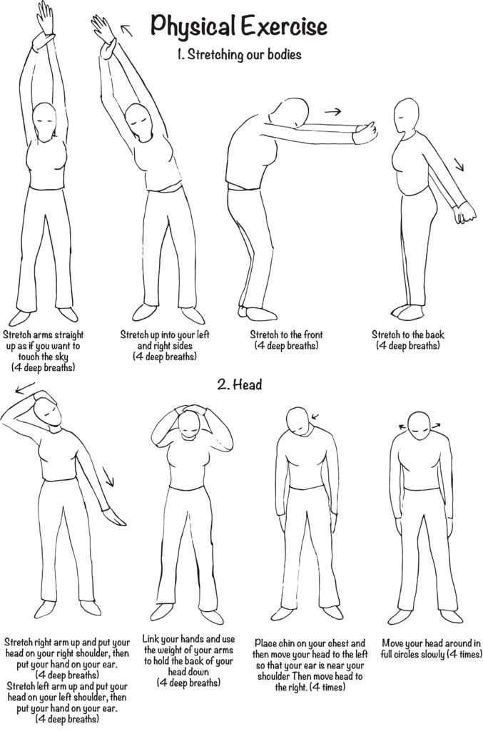

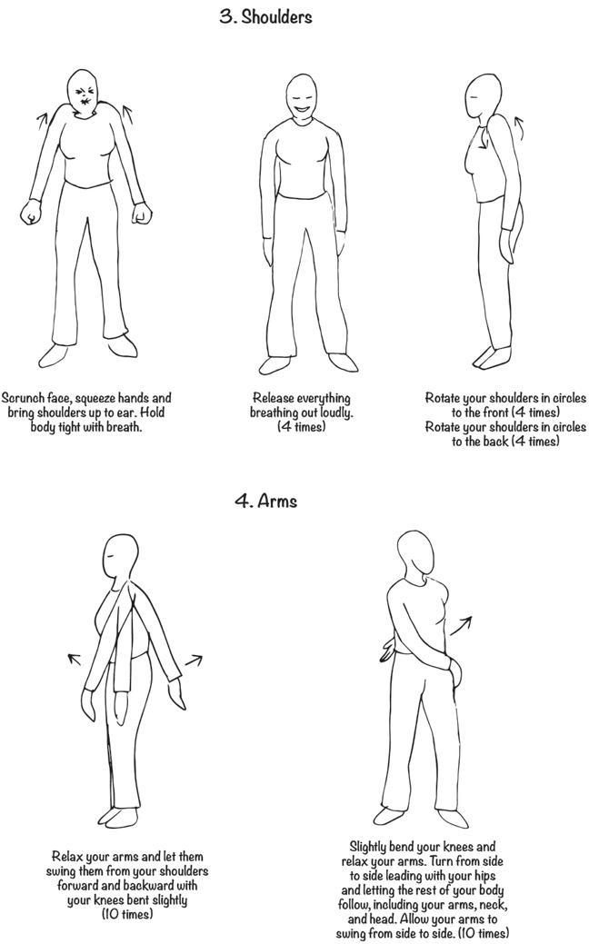

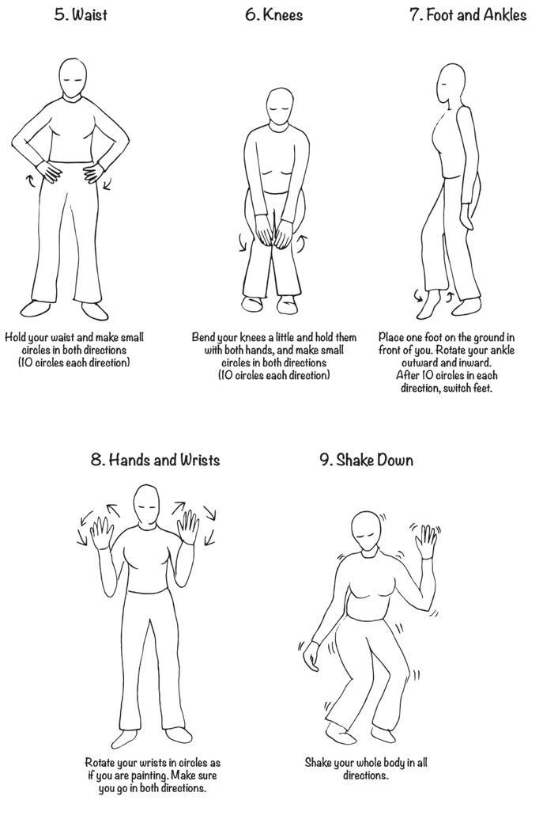

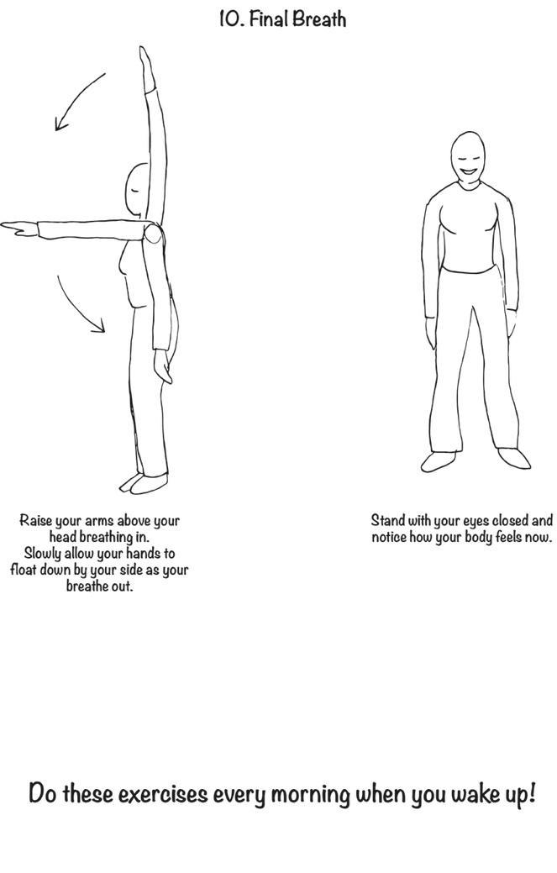

#### 

### Module 3: Live Demo of Onboarding Session (45 min)

#### Introduction to the onboarding session (5 min)

###### Overview

You and your co-trainer will lead a live demo for the onboarding session with facilitators. During this demo, you'll play the role of the "facilitator," and the facilitator will act as the "parents."

Remember to follow the A-E-C-P approach during the demonstration.

###### Instruction ([Slide](https://docs.google.com/presentation/d/1EXuJBIEbd-WohBCFeso0FmL0TNwOnl8fi36HQT_hrsE/edit#slide=id.p47))

Share with the facilitators that now you will be demonstrating the onboarding session were you will play the role of “facilitators” and they will play the role of “parents”.

During the demonstration, ask the parents to reflect on:

* The facilitation skills used by the trainer and co-trainer
* How was their experience as parents?
* What are the areas that parents might find challenging during the onboarding session?

Using the powerpoint slides, share the:

* Objectives of the onboarding session
* Onboarding Session agenda

#### 

#### Live Demonstration of Getting Started with Crianza con Conciencia+ chatbot (40 min)

##### Demonstration: Introduction to Phone Use (5 min)

###### Overview

The overview and instructions for this activity can be found in Getting Started with Crianza con Conciencia+ chatbot in your Facilitator Guide.

###### Instructions ([Slide](https://docs.google.com/presentation/d/1EXuJBIEbd-WohBCFeso0FmL0TNwOnl8fi36HQT_hrsE/edit#slide=id.p49))

Share with the participants that:

* The facilitators should model all the basics of operating a mobile phone (even if they can do it already).
* This activity will help parents understand the basics of operating a mobile phone (if they cannot do that already) and start interacting with the Crianza con Conciencia+ Chatbot chatbot.

Share the checklist of the demonstrations facilitators should make

* Switching the phone on and off
* Navigating through phone settings - brightness, installing/uninstalling apps, taking and sharing screenshots
* Navigating through WhatsApp Settings - responding to messages
* Charging the phone
* Switching the data bundle on and off
* Managing internal phone storage
* Digital safety
* Preventing damage from the phone

Remind the participants to provide assistance based on individual needs, especially for those who may not be familiar with using a mobile phone.

Ask the participants if they have any questions.

##### Demonstration of Crianza con Conciencia+ Chatbot Onboarding (20 min)

###### Overview

The overview and instructions for this activity can be found in Getting Started with Crianza con Conciencia+ Chatbot in your Facilitator Guide.

* Help participants access Crianza con Conciencia+ Chatbot via WhatsApp. The trigger mentioned in the slide may be different from the ones parents will be using. Please check the facilitator manual on Formando Conciencia+ for the correct trigger word.
* You should model how to begin their interaction with the Crianza con Conciencia+ chatbot
* This activity will help participants start interacting with the Crianza con Conciencia+ Chatbot chatbot.

Instructions

Follow the instructions in the Facilitator Guide:

Take them through the following steps and respond to any questions or challenges that come up. Ensure that everyone has completed the previous step before moving on to the next one.

1. Start a WhatsApp chat with Crianza con Conciencia+ chatbot

Give participants the following instructions:

* Open your phone.
* Save the Crianza con Conciencia+ chatbot phone number (56 5100 6984) as a contact.
* Open WhatsApp, search for ‘Crianza con Conciencia+’ and start a chat by typing **ENTRENAR.** Remind the participants that this trigger word is different from the one they will use with the parents. Ask them to consult the Facilitator onboarding guide for the correct trigger word.

| Note  Before the next step, the Crianza con Conciencia+ chatbot will generate a 6-digit number as a unique identifier for each parent. At the end of the onboarding session, facilitators will associate the parent’s unique identifier with the facilitator’s Formando Conciencia+.  Refer to the "How to Report on Programme Delivery" section in the Facilitator Guide on Formando Conciencia+ for guidance on this process. |
| --- |

1. Settings:

Tell participants to follow the Crianza con Conciencia+ prompts. Crianza con Conciencia+ will ask them to:

* Type their first and last name
* Choose their gender
* Choose their state
* Choose their relationship status
* Type their girl or boy’s name.
* Girl or boy’s Gender
* Girl or boy’s date of birth

1. Introduction video:

Ask participants to pause when the 5-minute introduction video explaining how Crianza con Conciencia+ works comes up on their chatbot.

Play the video on the screen. Ask participants if they have any questions.

1. User information

Tell participants to follow the Crianza con Conciencia+ prompts. Crianza con Conciencia+ will ask them to:

* + Choose how they would like to receive the messages
    - Text, Images, and Videos
    - Text, Images, and Audio
    - Text and Images Only

| Note  If the parent has multiple boys, girls, or teens, ask them to choose the girl, boy, or teen that exhibits the most behavior issues when enrolling in the programme. Remind the parent that the lessons they earn through the program can be applied to all boys, girls, or teens. However, for the duration of the programme, ask the parent to focus only on one girl or boy. |
| --- |

1. Self-care

We will learn a short relaxation exercise that participants can use whenever they feel stressed or angry. This is a great parenting tool and life skill.

Tell participants to follow the Crianza con Conciencia+ prompts. Crianza con Conciencia+ will ask them to do the self-care exercise.

Play the video or audio for the whole group and practice the exercise together.

Ask the parents if they have any questions about the exercise.

1. Stop

Make sure that parents stop using Crianza con Conciencia+ before going on to the first lesson.

Praise participants for completing their first Crianza con Conciencia+ activities!

##### 

##### Demonstration of Resolving Challenges with Crianza con Conciencia+ (10 min)

Overview

Participants may encounter some challenges while interacting with the Crianza con Conciencia+ chatbot. Show the participants how to troubleshoot issues with the chatbot.

Instructions ([Slides](https://docs.google.com/presentation/d/1EXuJBIEbd-WohBCFeso0FmL0TNwOnl8fi36HQT_hrsE/edit#slide=id.p54))

Ask participants to show each other how to solve the following challenges:

* I am stuck in Crianza con Conciencia+, or the ‘Next’ button does not appear.
  + Type SIGUIENTE to navigate to your next activity.
* I don’t know how to access the main Menu or what the Menu does.
  + Type MENU at any time to:
    - Track your progress
    - Change settings (how/when you receive messages, update your details for tailored content)
    - Watch the onboarding video again and get tips to navigate Crianza con Conciencia+.
    - Get help with navigating specific challenges in applying new skills.
* I have an emergency and need immediate help.
  + Type HELP at any time to access resources and contact details in your community if you need assistance around family violence, sexual violence, mental health, or other emergencies.

##### Questions (5 min)

###### Instructions

Ask the following questions. Wait for 1-2 minutes before moving on to the next question. Wait for a few minutes for everyone to share before moving on to the next question. Use A-E-C-P while reading the responses of the participants.   
  
You can also ask participants to raise their hands if they want to share. Allow 2-3 participants to share. Make sure they are brief in their responses.

* Launch the poll in the zoom with the following question:

How was your experience as parents experiencing the onboarding session?

Responses

* 😄 Loved it!
* 😊 Informative and Nice
* 😐 Okay, Mixed Feelings
* 😢 Had Some Challenges
* 🥰 Absolutely Enjoyed!
* Discussion about the first experience with Crianza con Conciencia+

Ask participants to share in the chat if they have any questions after taking a pause. You can prompt them by asking the following:

* + How was your experience interacting with Crianza con Conciencia+?
  + Do you have any questions about how to interact with Crianza con Conciencia+?
  + Do you have any concerns with how you will interact with Crianza con Conciencia+ when you are at home?

**Note:** You only have to ask a few of these questions. The main point is to get them to start thinking about their role as a facilitator!

### 

### Module 4: Setting up Formando Conciencia+ App (5 min)

Formando Conciencia+ is designed especially for facilitators to deliver Crianza con Conciencia+ and simplify their efforts in providing online support to the parents. With Formando Conciencia+, facilitators can efficiently deliver weekly content and gather the necessary data with minimal hassle. The structured layout and intuitive design of Formando Conciencia+ ensure that all essential functions are easily accessible.

A key feature of the App is the scripted message that provides the structure for the WhatsApp chat session. The WhatsApp groups led by trained facilitators are designed to support parent engagement in the Crianza con Conciencia+ chatbot. The role of the facilitator is to draw parents into the chatbot and create a safe space that encourages meaningful sharing among them. This requires facilitators to share pre-scripted messages via the Formando Conciencia+ App.

Formando Conciencia+ also contains a Facilitator Guide that provides guidance to facilitators on how they should conduct the in-person session, and report attendance and safeguarding issues.

Please search for Formando Conciencia+ from the Google Play store. If you do not have access to the Google Play store, you can access the web version of Formando Conciencia+ [here](https://plh-facilitator-mx.web.app/template/home_screen).

Open the Formando Conciencia+ on your computer and share the screen with the facilitators for this module.

Instructions ([Slide](https://docs.google.com/presentation/d/1EXuJBIEbd-WohBCFeso0FmL0TNwOnl8fi36HQT_hrsE/edit#slide=id.p58))

* Introduce Formando Conciencia+ App to the facilitators:
  + Formando Conciencia+ App is designed to support facilitators during the Crianza con Conciencia+ Programme Delivery.
  + Facilitators will use the Formando Conciencia+ App to:
    - Add parents to Formando Conciencia+ App
    - Access Facilitator Guide for delivering in-person session
    - Conduct chat session
    - Handle safeguarding issues
* Play the video of setting up the profile of the facilitator on the App. Ask the facilitators to follow the video (Slide)
* Open [the web version of Formando Conciencia+ App](https://plh-facilitator-mx.web.app/template/home_screen) on your computer device and share it on the webinar.
* Ask all the participants to open the app on their phones.
* Guide the participants in setting up their profile on the App.
* Provide an overview of the Formando Conciencia+ App interface, covering the following key sections
  + The three buttons at the bottom of the App for Reporting Attendance, Home, and Profile:



* + The five sections of the home screen
    - Facilitator Guide
    - Chat Sessions
    - Frequently Asked Questions
    - Common Challenges
    - Safeguarding
  + The Menu bar on top right is for giving feedback.

### 

### Closing (10 min)

Instructions

Review what you have covered in the workshop so far:

* Background, overview, and structure of Crianza con Conciencia+
* Accept, Explore, Connect, and Practise as facilitation skills
* Setting up Formando Conciencia+ App
* Live Demo of the onboarding session (the rest of the demo will continue tomorrow)

Assign the following home activities to the facilitators:

* Review the facilitation skills you learned today - especially the AECP method.
* Ask the participants to go through all the lessons in Crianza con Conciencia+ chatbot. At the end of each lesson, ask them to type NUEVO to start a new lesson.
* If the participants are facing any issues, they can restart their chatbot by typing REANUDAR.
* Remind the participants that these triggers are only for them during the training, and NOT to be shared with the parents during onboarding session.
* Share the agenda of Day 2 of the workshop

Ask the facilitators to share in Q&A if they have any questions about the workshop.

## 

## Day 2: Facilitator Training Workshop

### Overview of the Session

| Goals of the session | * Participants can use the Formando Conciencia+ App to connect parents’ unique identifier, and report attendance. * Participants can facilitate chat sessions on self-talk * Participants can provide parents support with troubleshooting and safeguarding | | | | |
| --- | --- | --- | --- | --- | --- |
| Materials | * Laptop, Internet Connection, Zoom Webinar Credentials | | | | |
| Preparation | * Check all the relevant technology before the session. * All the participants should have access to the Crianza con Conciencia+ chatbot and Formando Conciencia+ App * Polls and quizzes for the workshop should be set up in advance * All participants should have access to a laptop, stable internet connection, and a smartphone | | | | |

| Day 2 Session Agenda | | | | | | |
| --- | --- | --- | --- | --- | --- | --- |
| Module | | Activity | | Zoom Preparation | Time | |
| Beginning of the Day Two Activities | | * Welcome * Reminders * Check-in * Take a Pause * Questions and Reflections from Day One | | Emotional Check-in zoom poll | 15 min | |
|
| Module 5: Preparing for the Chat Session | | * Setting up the WhatsApp Group * Setting up Ground Rules for WhatsApp Chat Session * Setting Expectations for Facilitator’s Role * Adding Parents to Formando Conciencia+ * How to report attendance | |  | 25 min | |
| Module 6: Conducting WhatsApp Chat Session | | * Introduction to WhatsApp Chat Session * A-E-C-P in WhatsApp Chat Session * Pop Quiz | | A-E-C-P in WhatsApp Pop Quiz | 35 min | |
|
| Looking Around - Energizer (5 min) | | | | | | |
| Module 7: Safeguarding | | * What is safeguarding? * Understanding abuse, neglect, and exploitation * Safeguarding in Crianza con Conciencia+ chatbot * Safeguarding in in-person and online sessions * Role of Facilitator in safeguarding | |  | 10 min | |
| Module 8: Addressing Challenges | | * Addressing common challenges * Questions | |  | 20 min | |
| Closing | | * Loving Kindness Exercise * Circle of Appreciation * Next Steps | |  | 15 min | |
|
|

### Beginning of Day Two Activities (15 min)

###### Instructions ([Slide](https://docs.google.com/presentation/d/1EXuJBIEbd-WohBCFeso0FmL0TNwOnl8fi36HQT_hrsE/edit#slide=id.p67))

Begin Day Two of the Facilitator Training Workshop with the following activities:

1. Welcome each participant as they arrive – try to learn their names!
2. Welcome the entire group to begin the session:
   * Praise the participants for making the effort to come to the session amidst their busy lives;
   * Try to start on time to model this for their own groups.
3. Remind the trainees:
   * Display their name to full name, name of the organisation, and their city
   * Their audio is automatically muted when they enter the session. If they would like to speak, they can raise their hand.
   * This session is being recorded for documentation purposes. The participants are giving permission to be recorded by attending the session.
   * They can use the Chat feature to respond to the questions asked by the trainer.
   * They can use the Q&A feature to ask questions to the trainer and co-trainer about Crianza con Conciencia+.
4. Begin the working by taking the pause - play the Take a Pause video.
5. Launch the emotional check-in zoom poll

How are you feeling today?

Responses:

* ☹️ *Not great*
* 😐 *Just okay*
* 😊 *Feeling good*
* 🌟 *Feeling amazing!*

1. Ask the participants to take a moment and reflect from their learnings from yesterday. Ask them to share one key takeaway from yesterday’s sesion in the chat.

As the participants are sharing, prompt them with the following guiding questions:

* How does the skills you learnt yesterday help you with your facilitator role?
* How was it experience the Crianza con Conciencia+ chatbot?
* Do you have any concerns or challenges you anticipate as your continue to implement the strategies you learnt?

Spend a few minutes reviewing and discussing key responses from the chat. Remind the participants that they are free to engage with others' reflections and share their own insights.

Remember that you are modelling how to deliver the programme to parents, so try to be active, engaging, and positive!

### 

### Module 5: Preparing for the Chat Session (25 min)

###### Overview

You have demonstrated to the facilitators how to guide parents through onboarding into the chatbot. In this section, you will guide facilitators to set up for their WhatsApp chat session. For providing online support, Formando Conciencia+ App contains all the information needed by the facilitators.

In this section, you will walk the facilitators through the steps to prep for the weekly chat sessions:

* Setting up the WhatsApp Group
* Setting up Ground Rules for WhatsApp Group
* Setting expectations of the Facilitator’s role
* Connecting Formando Conciencia+ with Parent’s UID
* Reporting attendance on Formando Conciencia+ App

#### 

#### Setting up the WhatsApp Group (3 min)

###### Instruction ([Slide](https://docs.google.com/presentation/d/1EXuJBIEbd-WohBCFeso0FmL0TNwOnl8fi36HQT_hrsE/edit#slide=id.p75)):

Remind the participants that they should aim to set up their WhatsApp Group before the onboarding session.

Please make sure you have done the following before the onboarding session starts:

* Save the names and WhatsApp numbers of the parents assigned to you on your phone (if available) so you can easily confirm details during the onboarding session.
* Create your WhatsApp group (with temporary group name, icon, description). The name of each WhatsApp group has the same structure:
  1. “Familias Conciencia+”
  2. A name selected by the group.

When you create your temporary group name, you will use "Crianza con Conciencia+”

You can keep your temporary group name or add a name to the temporary group name.   
For example, “Familias Conciencia+_HappyFamilies”.

#### 

#### Setting up Ground Rules for WhatsApp Chat Session (5 min)

###### Instructions ([Slide](https://docs.google.com/presentation/d/1EXuJBIEbd-WohBCFeso0FmL0TNwOnl8fi36HQT_hrsE/edit#slide=id.p76))

Share the following instructions on how the facilitators will be setting the ground rules for the WhatsApp Chat Session:

For the WhatsApp group to be a safe and comfortable space for everyone, ask the participants to think about what is important to them to feel comfortable, respected, safe and supported in the group.

Crianza con ConCiencia+ is a special programme! It brings families together to learn and share common experiences with each other.

When discussing Ground Rules, you can use the following format:

* Put up one flipchat and write at the top: Ground rules
* Ask participants to share their suggestions.
* Writes rules and comments on the flip chart to keep for later reference.
* **Make sure Ground Rules describe positive behaviour.** You can prompt for rules on specific issues like cell phone use, respect, etc.
* You can repeat what you hear and explore the rules to ensure everyone in the group agrees and understands.
* For example, if someone mentions “Respect”, ask what that means to her or him. What sort of behaviour shows “Respect”?
* Make sure everyone agrees and has the opportunity to contribute before moving on to another suggestion.

Some ideas for ground rules for WhatsApp Group:

* Respect the privacy of personal pictures and videos that are sent to the chat group.
* Everyone is different and will have different experiences to share.
* Respect each other by paying attention and taking turns to share and listen.
* What we say in the group stays in the group – both in-person and online.
* Share only what you feel comfortable to share.
* Discussion on the WhatsApp group will focus on parenting only.
* Feel free to ask any questions!

Remind the participants to update the Group’s Description after the ground rules are agreed upon during the onboarding session.

Invite participants to suggest additional ground rules in the chat for an online chat session. Spotlight 2-3 noteworthy suggestions from the chat and share them with the broader group for consideration and discussion.

#### Setting Expectations for Facilitator’s Role (2 min)

###### Instruction [(Slide)](https://docs.google.com/presentation/d/1EXuJBIEbd-WohBCFeso0FmL0TNwOnl8fi36HQT_hrsE/edit#slide=id.p79)

After the onboarding session, the facilitator’s role is to:

* Check in every few days till the end of the course
* Make sure all the parents are following the ground rules discussed earlier
* Pose questions on parenting for discussion
* Report any case of abuse of girls, boys, adolescents, and adults.
* Leave once the programme is completed. However, parents can continue learning through Crianza con Conciencia+. By the end of the year, there will be new courses on Crianza con Conciencia+.

#### Adding Parents to Formando Conciencia+ (10 min)

* Show the video of demonstration on Formando Conciencia+ App on how to add a parent and how to add a co-parent.
* Facilitators can find this information in Formando Conciencia+ under “How to Add Parents & Report Attendance” in the Facilitator Guide section
* Share the parent and co-parent profile from the slide and ask the facilitator to add them to their group.
* Instructions on adding a parent and co-parent
  + How to Add a parent:
    - Select the profile icon from the bottom navigation bar.
    - Choose “Add Parent”
    - Enter parent details in the form. To enter the parent’s unique identifier (UID), ask them to text “ID” on Crianza con Conciencia+ Chatbot. Copy the 6-digit number into the parent profile
  + How to Add a Co-Parent
    - If two parents are participating in the programme, together, you must link their accounts.
    - Once you have added the first parent profile, to add a second parent, select “Add Parent.”
    - Enter parent details in the form. To enter the parent’s unique identifier (UID), ask them to text “ID” on Crianza con Conciencia+ Chatbot. Copy the 6-digit number into the parent profile.
    - Select “Add Co-Parent”
    - Select the co-parent from available parent user profiles.
    - Select “Save.”
    - Both parent profiles will be updated to note the co-parent.
  + Give the participants a few minutes to follow the video.
* Ask the participants to try it on their App using the hypothetical parent’s information on the slides

#### How to Report Attendance (5 min)

* Play the video on the slides and demonstrate the following on the Formando Conciencia+ App
  + Select the pencil icon from the bottom navigation bar.
  + Select whether you are reporting on an in-person or WhatsApp session with your parents.
  + Remind the participants that they must report attendance for their parents after every in-person and WhatsApp session.
  + Complete the report.
  + In case the facilitator wants to edit the report:
    - Select the pencil icon from the bottom of the navigation bar.
    - Select whether the session you want to edit was an in-person or WhatsApp session.
    - Select the session that you want to edit.
    - Your previous selections will appear. You can now edit your selections and select “Save”
  + Ask the participants if they have any questions about reporting attendance
  + Tell facilitators that there will also be a checklist where they can report whether they have done all the activities

### 

### Module 6: Conducting WhatsApp Chat Session (30 min)

#### Introduction to WhatsApp Chat Session (5 min)

I**nstructions (**[**Slide**](https://docs.google.com/presentation/d/1EXuJBIEbd-WohBCFeso0FmL0TNwOnl8fi36HQT_hrsE/edit#slide=id.p84)**):**

* Explain to facilitators that the WhatsApp groups in Crianza con Conciencia+ are to provide parents with additional support on parenting skills during the programme
* Ask the participants to look for the "Chat session" section on Formando Conciencia+ homepage
* Show participants the chat sessions:
  + After onboarding session
  + Day 3: Self-talk
  + Day 5: Saying Goodbye
* Play the video of how facilitators share messages using the Formando Conciencia+:
  + Once you're on the content for that week, locate the "Share" icon. It's typically represented as an arrow pointing upward or a box with an arrow, and it's used to share content.
  + Click on the "Share" icon.
  + In the menu that appears, select "WhatsApp" as your sharing option. Choose your WhatsApp group from the list.
  + Before you hit the "Send" button, make sure to add any necessary information
  + Finally, click the "Send" button to share the content with your WhatsApp Group.

#### A-E-C-P in WhatsApp Chat Session (15 min)

###### Overview

In this section, you will demonstrate the core facilitation skills of Accept, Explore, Connect, and Practise in the whatsapp chat session.

###### Instruction ([Slide](https://docs.google.com/presentation/d/1EXuJBIEbd-WohBCFeso0FmL0TNwOnl8fi36HQT_hrsE/edit#slide=id.p86))

* Share with the facilitators that on day 3, they will be leading a WhatsApp chat session on self-talk. All the messages that they need to send are pre-drafted in Formando Conciencia+. They will now see an example of A-E-C-P used during the chat session on self-talk.
* Walk the facilitators through the WhatsApp interaction between a facilitator and parent. You can read the facilitator’s message, while your co-trainer reads the parent’s message.
* Highlight the ways in which the facilitator used Accept, Explore, Connect, and Practice.

#### Pop Quiz (10 min)

###### Overview

This multiple choice pop quiz will help the facilitators check their understanding of Accept, Explore, Connect, and Practice in a WhatsApp chat format.

The participants will be posed with a parent statement, and they have to choose the best facilitator response from the options:

###### Instructions:

Set up the following quiz as **multiple-choice questions:**

| Question | Responses | Correct Answer |
| --- | --- | --- |
| Parent: I can’t help feeling overwhelmed when my child misbehaves. | * It’s a very common feeling and every parent learns to deal with it over time. * It’s tough when your child misbehaves. Can you share more about what overwhelms you in those moments? * The feeling of overwhelm will eventually pass as your child becomes older. Keep at it, and you will be fine. | * It’s tough when your child misbehaves. Can you share more about what overwhelms you in those moments? |
| Parent: I don’t understand why my teenager is so irritable lately! | * You know how teengers are, it is just a phase. * That sounds challenging. Can you share a time when they were irritated? * Don’t overthink it. Be glad they are not doing anything risky. | * That sounds challenging. Can you share a time when they were irritated? |
| Parent: I think this course is not related to my life and my problems. | * Maybe you are not able to understand. Keep trying it again. * It’s normal to feel that way, just keep going through the course. * I understand it might feel all new. Can you share more about what problems you are struggling with? | * I understand it might feel all new. Can you share more about what problems you are struggling with? |
| Parent: Thanks for the chat. I appreciate the support. | * I am glad I could help. Remember, you are not alone, and it’s okay to ask for help. * You will figure things out eventually. * No problem, you are strong. You don’t need much help. | * I am glad I could help. Remember, you are not alone, and it’s okay to ask for help. |

After the quiz is ended, highlight the principles behind the correct response.

| Responses | Correct Answer | A-E-C-P Principles |
| --- | --- | --- |
| Q: Parent: I can’t help feeling overwhelmed when my child misbehaves. | | |
| * Don’t worry about it. Every parent learns to deal with these things over time. * It’s normal to feel overwhelmed when your child misbehaves. Can you share more about what your child is doing in those moments? * The feeling of overwhelm will eventually pass as your child becomes older. Keep at it, and you will be fine. | * It’s normal to feel overwhelmed when your child misbehaves. Can you share more about what your child is doing in those moments? | It's important to recognize and ACCEPT the parent’s emotions when they are dealing with challenging situations with their child. Ignoring or brushing off these feelings may not help in understanding and resolving the issues. Then you can EXPLORE the situation in more detail with the parent. |
| Q: Parent: I don’t understand why my teenager is so irritable lately! | | |
| * You know how teengers are, it is just a phase. * That sounds challenging. Can you share a time when they were irritated? * Don’t overthink it. Be glad they are not doing anything risky. | * That sounds challenging. Can you share a time when they were irritated? | When the teenager seems distant, taking time to understand the reasons behind it is crucial for the parent. Explore how the teenager might have felt using open-ended questions.  Simple solutions might not cover the complexities of their feelings and situations, and may lead to poor relationship between the teen and the parent. |
| Q: Parent: I think this course is not related to my life and my problems. | | |
| * Maybe you are not able to understand. Keep trying it again. * It’s normal to feel that way, just keep going through the course. * I understand it might feel all new. Can you share more about what problems you are struggling with? | * I understand it might feel all new. Can you share more about what problems you are struggling with? | If the parents feel the program concepts are disconnected from their life, it's okay. Exploring their struggles can help bridge that gap and make the program more relevant to their experiences. |
| Q: Parent: Thanks for the chat. I appreciate the support. | | |
| * I am glad I could help. Remember, you are not alone, and it’s okay to ask for help. * You will figure things out eventually. * No problem, you are strong. You don’t need much help. | * I am glad I could help. Remember, you are not alone, and it’s okay to ask for help. | By emphasising empathy in our responses, we create a space where individuals feel heard, supported, and encouraged to seek assistance when necessary. |

### 

### Energizer - Looking Around (5 min)

###### Overview

This is an energiser break for the group to get moving before diving into the second half of the workshop. Make sure you and your co-trainer demonstrates the physical exercise. Encourage all the participants to switch on their video for the energiser break.

Make sure that you take into consideration any movement limitations or disabilities that may be present in the group. It is very important to make sure the movements are smooth and the breath relaxed. It is also important that the participants’ bodies are relaxed – especially arms, legs, neck, shoulders.

You read out loud the following text below.

###### Instructions [(Slide)](https://docs.google.com/presentation/d/1EXuJBIEbd-WohBCFeso0FmL0TNwOnl8fi36HQT_hrsE/edit#slide=id.p106)

* Ask all participants to stand up. Tell them that you are going to give them instructions on which direction to look. They have to turn their head (only their head, not the body) and look in the appropriate direction.
* Explain the details. When you say, “Up”, the participants should tilt their head and look at the ceiling (or the sky). When you say, “Down”, the participants should lower their head and look at the floor (or their feet). When you say, “Left”, the participants should turn their head to their left. When you say, “Right”, the participants should turn their head to the right.
* Give directions. Say the words up, down, left, and right in a random order and encourage the participants to follow your instructions. Keep giving directions at a fairly rapid pace.
* Change the meaning of the words. After about a minute, tell the participants that you are going to make a change. From now on, up will mean down and vice versa. So when you say “Down”, the participants should look up at the ceiling. Similarly, when you say “Up”, the participants should look down at their feet.
* Explain that the meaning of the words left and right remain the same. Call out the four directions in a random order and ask the participants to follow instructions. Remind them, however, that they have to remember the new meaning of the words up and down. You will see many “mistakes” and lots of embarrassed laughter.
* Conclude the session. Announce the end of the activity after about another minute.

### 

### Module 7: Safeguarding (10 min)

###### Overview

In this section, you will walk the facilitators through how to ensure a safe and supportive environment for all the parents in Crianza con Conciencia+.

You will cover:

* What is safeguarding?
* Understanding abuse, neglect, and exploitation
* Reporting Sexual Exploitation and Abuse allegations against PLH employees
* Safeguarding in Crianza con Conciencia+ chatbot
* Safeguarding in in-person and online sessions
* Role of Facilitator in safeguarding

###### Instruction ([Slide](https://docs.google.com/presentation/d/1EXuJBIEbd-WohBCFeso0FmL0TNwOnl8fi36HQT_hrsE/edit#slide=id.g2b6ebb0ae01_0_178))

Follow the slides to cover the following information:

Safeguarding means protecting the health, well-being, and human rights of people and enabling them to live free from harm, abuse and neglect. Regardless of age, gender identity, disability, sexual orientation, religious or ethnic origin, everyone we come into contact with has the right to be protected from all forms of harm, abuse, neglect and exploitation by any person associated with this programme.

Understand abuse, neglect and exploitation:

* Abuse refers to a deliberate act of maltreatment that can damage a child’s security, wellbeing, dignity and development. Abuse includes all forms of physical, sexual, psychological and emotional maltreatment. (Save the Children definition)
* Violence against children is defined as forms of physical or mental violence, damage and abuse, neglect or neglectful treatment or maltreatment or exploitation, including sexual abuse. (Office of the High Commissioner for Human Rights, 1990, Article 19)
* Child exploitation refers to using the child for economical or sexual benefit, for gratification or profit, often resulting in unjust, cruel and harmful treatment of the child. (Save the Children definition)

Safeguarding Support in Crianza con Conciencia+ chatbot:

Crianza con Conciencia+ chatbot is automated to recognise high-risk keywords and detect disclosure of dangerous and violent situations. After detection, an empathetic and empowering response is offered along with the contact details of where to access professional or urgent help (e.g., police, ambulance, hotline) also includes information on local support resources and hotlines to further support self-referral for users. Parents can also access the safeguarding support by typing HELP in the ParentText chatbot.

Safeguarding Support in in-person and online sessions:

It is also important for you and the facilitators to know the following guidelines for handling disclosures of abuse, neglect, and violence from participants during in-person and online sessions:

Know your organisation’s child safeguarding policies and referral procedures

* All organisations should have or develop child rights safeguarding policies and referral procedures, including details on how to respond appropriately when a parent or child discloses abuse.
* You and the facilitators should have accurate knowledge of all protocols and response plans. These will tell them what to do within your organisation if a parent or child reports abuse (e.g. who to report to, internal resources for supporting the child), as well as how to engage outside resources (e.g. local referral pathways, when to engage with authorities).
* It is the facilitators’ responsibility to act regardless of whether they are responding to disclosures of past and/or present abuse. However, they are not responsible for resolving the situation on your own. It is important that they discuss the situation with their supervisor to agree on what steps to take next.

Ensure parents know that you are someone who can help.

* Parents participating in the sessions need to know that they can come to the facilitators for help, regardless of when abuse occurred.
* Facilitators should make sure that the parents know that they can trust them and that they will listen and support the parents without judgement or any further harm.

What should the Facilitator do during the disclosure of abuse, neglect, or exploitation?

* Provide a safe environment in which the participant can share their story.
* Listen carefully to the participant and take notes: what/when/where/who.
* Determine if the participant is in immediate danger and what help is available.
* Make sure that the participant feels that the facilitator believes them.
* Let them know they have done the right thing by sharing their story with the facilitator.
* Be supportive and free of judgment in their responses – avoid blaming at all times!
* Let the participant know that the facilitator will share what he/she told them with their supervisor to find a way to support and protect him/her.
* Explain what the facilitator is going to do next.
* Notify their supervisor.

### 

### Module 8: Addressing Challenges (20 min)

###### Overview

As facilitators, they might encounter various challenges during the delivery of Crianza con Conciencia+. In this section, your goal is to support the facilitators by acknowledging some of the real-life issues and exploring some suggested solutions to navigate through them.

You will walk through some of the challenges and share suggested solutions with the facilitators.

###### Instructions ([Slide](https://docs.google.com/presentation/d/1EXuJBIEbd-WohBCFeso0FmL0TNwOnl8fi36HQT_hrsE/edit#slide=id.p115))

Share with the facilitators that beyond the challenges discussed today, if they need support, there are ways to find solution:

* Explore the FAQ section of Formando Conciencia+
* Explore Common Challenges section of Formando Conciencia+
* Explore Safeguarding section of Formando Conciencia+
* Reach out to your supervisor

**Challenge 1:** A parent needs support accessing ParentText, and I'm not sure how to answer their question.

**Suggestion:** Reach out to your supervisor.

**Challenge 2:** A parent struggles to participate in WhatsApp Group

**Suggestions:** Explore FAQ on:

* Only a small group of parents are actively participating in the chat sessions, while other parents are not responding.
* What if no one participates?

**Challenge 3:** A parent triggered you emotionally in person or in a WhatsApp group.

Suggestions:

* It is normal to be affected by the experiences of parents or things that they say during the programme, especially if they relate to our own lives.
* Take a pause! Even a few deep breaths can be helpful to make sure that you respond in the moment in a constructive way rather than reacting negatively.
* Reach out for support. Talk to your supervisor or a co-worker about it if you feel comfortable.

**Challenge 4:** You are feeling nervous and anxious to deliver Crianza con Conciencia

**Suggestions:**

* You can always take a pause to deal with nervousness or anxiety.
* Prepare thoroughly by reviewing the materials, rehearsing the onboarding session, and thinking about potential questions the parents could ask.

**Challenge 5:** A parent can not commit to the ground rules

**Suggestion:** Follow guidance under “A parent cannot commit to the ground rules” in Formando Conciencia+

Encourage participants to reflect on potential challenges they may foresee in implementing safeguarding measures and share their thoughts in the chat. Trainers will then spotlight 3-5 prominent challenges and engage in a discussion to explore and propose effective solutions collaboratively.

##### Questions (10 min)

Ask the participants to share in Q&A if they have any questions about

* Preparing for the WhatsApp Chat Session
* Using A-E-C-P in the chat session
* Safeguarding
* Addressing common challenges
* Any other questions about the program.

#### 

#### Closing (15 minute)

##### Loving Kindness Exercise (5 min)

Overview

At the end of the session, participants learn one last stress reduction activity – a Loving Kindness exercise. This activity helps participants connect with a sense of loving-kindness towards themselves and their families. It brings closure to the culminating activity while reconnecting participants to a sense of wellbeing and calmness.

###### Instructions [(Slide)](https://docs.google.com/presentation/d/1EXuJBIEbd-WohBCFeso0FmL0TNwOnl8fi36HQT_hrsE/edit#slide=id.p124)

| ⭐Note  Use the below text as a guide for leading the activity. You can pause for about 5 seconds at each [Pause] in the text. It is helpful to follow your own instructions during the pause. |
| --- |

Step 1: Preparation

* Sometimes when we are experiencing stress, feeling alone, or just needing support, it can be helpful to send thoughts of loving kindness to ourselves.
* This exercise helps us to become more grounded and present – which increases well being and balance - helping us to manage stress, illness and difficulty. [Pause]
* Find a comfortable sitting position, your feet flat on the floor, your hands resting in your lap. [Pause]
* Close your eyes if you feel comfortable. [Pause]

Step 2: Becoming Aware

* Ask yourself, “What is my experience at this moment?” [Pause]
* Notice what thoughts you are experiencing. Notice if they are negative or positive. [Pause]
* Notice how you feel emotionally. Notice if your feelings are pleasant or unpleasant. [Pause]
* Notice how your body feels. Notice any discomfort or tension. [Pause]

Step 3: Opening to Loving Kindness

* Connect to your heart in a kind and gentle way. You may want to place one hand on your heart or chest. [Pause]
* You can then say the following words silently to yourself [Pause]

May I be peaceful. [Pause]

May I be safe. [Pause]

May I be healthy. [Pause]

May I be happy. [Pause]

May I feel loved. [Pause]

Repeat slowly once or twice taking your time between each phrase.

* If you feel comfortable, you can also send thoughts of loving-kindness to your child, your partner, your family, and anyone else who is close to you in your life. [Pause]

May you be peaceful. [Pause]

May you be safe. [Pause]

May you be healthy. [Pause]

May you be happy. [Pause] May you feel loved. [Pause]

Repeat slowly once or twice taking your time between each phrase.

Step 4: Expanding Awareness

* Allow your focus to expand to the whole body. [Pause]
* Allow your focus to expand to the sounds in the room. [Pause]

Step 5: Reflecting

* Take a moment to reflect on your experience.
* When you are ready, open your eyes. [Pause]

*Remember that you can do this activity at any time whenever you feel like you need extra support.*

##### Circle of Appreciation (5 min)

**Instructions**

This is the final Circle of Appreciation.

Encourage participants to write one thing they are proud of doing in this worksop, and compliment themselves.

##### Next Steps (5 min)

Praise the participants for attending the workshop and share the next steps with them:

* You will receive a certificate for completing the training
* You will receive an email with link to the Facilitator App and the chatbot
* You will conduct the onboarding session and report attendance on the onboarding session
* We will be reaching out to you to conduct interviews to learn from your experience in participating in the first ever Crianza con Conciencia+

Thank all the facilitators for participating in the workshop! Praise them for their efforts and contributions!

## 

## 

## 

## Appendix

### List of Triggers for Crianza con Conciencia+ Chatbot

#### For Facilitator Training

| ENTRENAR | Initiates programme |
| --- | --- |
| NUEVO | New Day |
| REANUDAR | Restart |
| SIGUIENTE | Next |
| MENÚ | Menu |

#### For Users

| INICIAR | Initiates programme |
| --- | --- |
| ID | Share research ID |
| SIGUIENTE | Next |
| MENÚ | Menu |
|  |  |

**Note:** Facilitators should not use the triggers intended for users, and vice-a-versa. It could lead to complications in engagement data.